Self-Regulation Handout

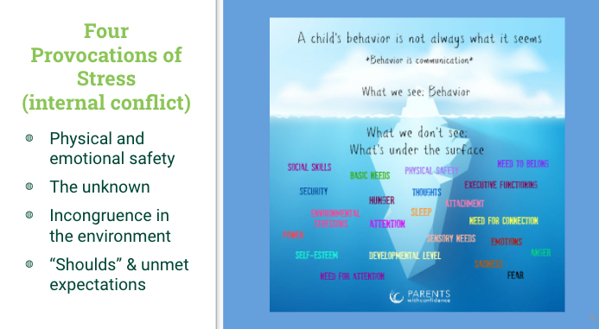

Assessing the Situation…

Provocation  of Stress | Locate your child’s behaviour(s) to assist in identifying what they might need in the way of support.  *this helps to reduce the feeling of being manipulated or that your child is just “seeking attention” and allows you to choose a suitable strategy or strategies and enlist appropriate support. | What does your child need?  *look at all the strategies and try to match accordingly
Physical and/or Emotional Safety |  | An increased sense of physical safety  A “bridge” to connect them to the space they need to occupy (preferably a human connection to help them orient themselves emotionally, to reduce the perception of threat)
The Unknown |  | Increased preparation, information front-loading, to help your child anticipate the new situation with a degree of confidence and identifiable skills
Incongruence in the Environment |  | The feeling of incongruence often produces confusion or that “red flag” feeling. Help your child put words to that feeling and where it is located in their body. They can realize that this feeling is actually helpful and a good skill to have to recognize authenticity in people and situations to help keep them safe.
“Shoulds” & Unmet Expectations |  | An increased growth mindset to help bridge the difference between where or who they are and what they hope to be. “I’m bad at math, and I just want to get away from it or avoid it” Right now, I don’t know how to do this particular thing in math, but with practice and asking questions, I will keep learning more until I can do it”.

By becoming more curious, you can also map the time of day certain behaviours occur, or particular environments where the behaviours are more prevalent. Looking for patterns allows a parent to make more targeted choices for attention.

Go slow to go fast.

